V 2021/08-01
Sub-Committee Jumping Hills

lnspection Report
In final report delete all remarks (blue) and replace “xxx” by text

Name report / file in the following way when saving to the computer:

Example: 190702_Tschagguns_HS108_inspection-report.pdf

- date of inspection day-month-year: ddmmyy
- underline
- name of hill
- underline
- HS
- underline
- inspection-report
- safe as *.pdf

Certificate number xxx

Date of Inspection xxx

Country xxx Place xxx

Owner of hill /address xxx

Billing address xxx

Name of Inspector xxx

Persons present during inspection xxx

Name of hill xxx

Size of hill (HS) xxx

h : n relationship xxx

Cardinal direction (inrun to outrun) xxx

Inrun with r1 as clothoide or as circle xxx

Most frequent wind direction (from - to) xxx

Transportation to start existing xxx

Warming area / WC existing xxx

Guard rail in e, r1 and t existing xxx

Guard rail in landing and r2 existing xxx

Actual state of hill xxx

Year of last change of the hill / what has been changed xxx

Remarks Xxx xxx xxx xxx

After all requirements and conditions (written RED), mentioned underneath, will be fulfilled, a new certificate for next 5 years can be issued.

Last inspection: date xxxxx inspector xxxxx
Following requirements then have been demanded to be fulfilled:
Xxxxxxxx fulfilled today yes / no
Xxxxxxxx fulfilled today yes / no
Xxxxxxxx fulfilled today yes / no

insert photo

A general view

Protocol of measurement

Remarks: delete following pictures and headings if not applicable

Remarks: delete following parameters if not applicable or – if not existing in the form – add new ones

ICR 2012 - 2020
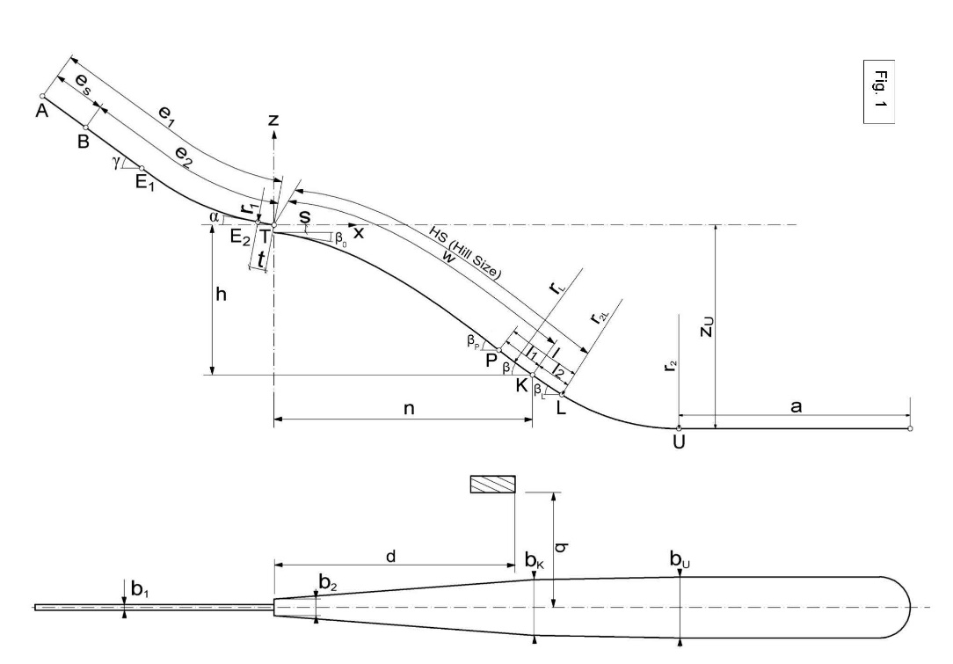
HS = | ….. | m | V₀ = | ….. | m/s | Normaldruck max. = | ….. | m/s²
h : n = | ….. | m | l = | ….. | m
e₁ = | ….. | m | l 1 = | ….. | m | P = | ….. | m
e2 = | ….. | m | l 2 = | ….. | m | K = | ….. | m
es = | ….. | m | a = | ….. | m | L = | ….. | m
t = | ….. | ° | β 0 = | ….. | ° | b 1 = | ….. | m
γ = | ….. | ° | β p = | ….. | ° | b 2 = | ….. | m
α = | ….. | m | β = | ….. |  | b K = | ….. | m
r 1 = | ….. | m | β L = | ….. | ° | b U = | ….. | m
h = | ….. | m | r L = | ….. | m | d = | ….. | m
n = | ….. | m | r 2L = | ….. | m | q = | ….. | m
s = | ….. | m | r 2 = | ….. | m | Zu = | ….. | m

ICR 2008 ff
HS = | ….. | m | V0 = | ….. | m/s | Normaldruck max. = | ….. | m/s²
e = | ….. | m | l 1 = | ….. | m | P = | ….. | m
es = | ….. | m | l 2 = | ….. | m | K = | ….. | m
t = | ….. | m | a = | ….. | m | L = | ….. | m
γ = | ….. | ° | β 0 = | ….. | ° | b 1 = | ….. | m
α = | ….. | ° | β p = | ….. | ° | b 2 = | ….. | m
r 1 = | ….. | m | β = | ….. | ° | b K = | ….. | m
h = | ….. | m | β L = | ….. | ° | b U = | ….. | m
n = | ….. | m | r L = | ….. | m | d = | ….. | m
s = | ….. | m | r 2L = | ….. | m | q = | ….. | m
 |  |  | r 2 = | ….. m |  | Zu = | ….. | m

ICR 1996 ff
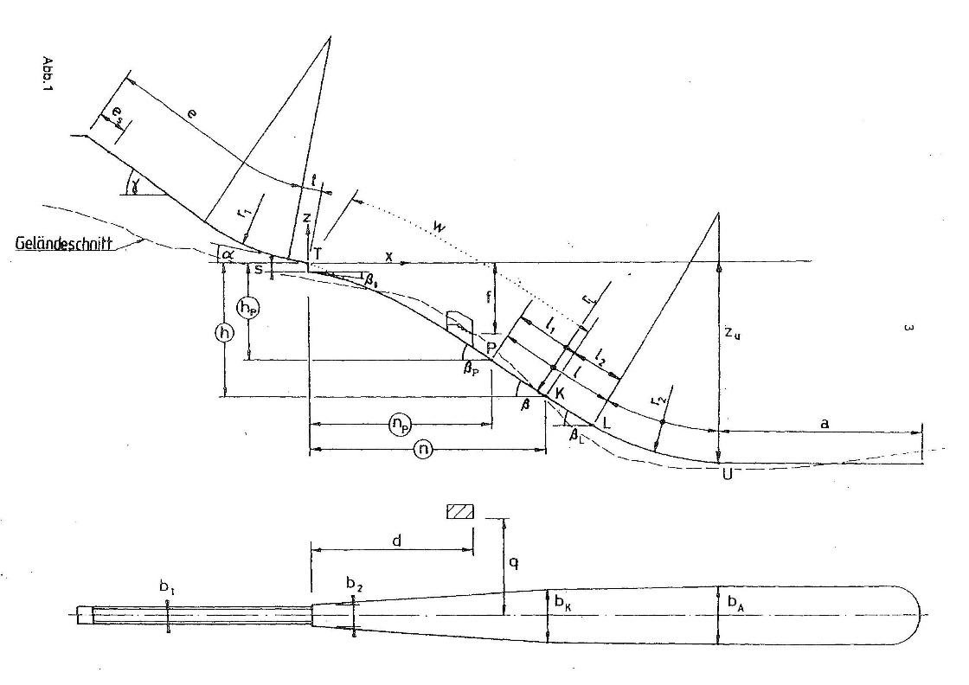
HS = | ….. | m | V₀ = | ….. | m/s | Normaldruck max. = | ….. | m/s²
h : n = | ….. |  | l 1 = | ….. | m | P = | ….. | m
e = | ….. | m | l 2 = | ….. | m | K = | ….. | m
es = | ….. | m | a = | ….. | m | L = | ….. | m
t = | ….. | m | β 0 = | ….. | ° | b 1 = | ….. | m
γ = | ….. | ° | β p = | ….. | ° | b K = | ….. | m
α = | ….. | ° | β = | ….. | ° | b A = | ….. | m
r 1 = | ….. | m | β L = | ….. | ° | d = | ….. | m
h = | ….. | m | r L = | ….. | m | q = | ….. | m
n = | ….. | m | r 2 = | ….. | m | f = | ….. | m
s = | ….. | m |  |  |  | Zu = | ….. | m

IWO/ICR before 1996
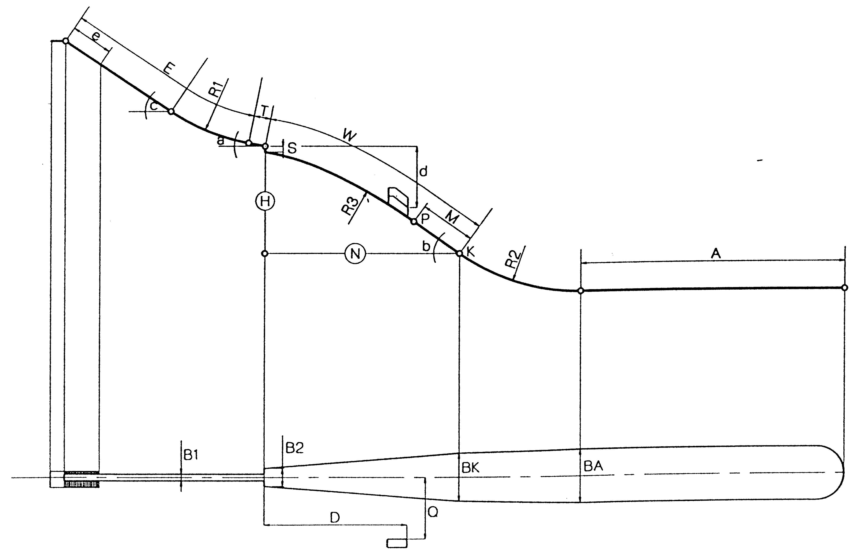
e = | ….. | m | V0 = | ….. | m/s | W = | ….. | m
E = | ….. | m | A = | ….. | m | P = | ….. | m
T = | ….. | m | b₀ = | ….. | ° | K = | ….. | m
c = | ….. | ° | b = | ….. | ° | B1 = | ….. | m
a = | ….. | ° | R1 = | ….. | ° | B2 = | ….. | m
H = | ….. | m | R2 = | ….. | m | D = | ….. | m
N = | ….. | m | R3 = | ….. | m | Q = | ….. | m
S = | ….. | m |  |  |  | d = | ….. | m

Number of Gates xxx

Distance between Gates xxx cm
(sloping distance edge to edge)

height of stairs xxx cm

step-width of stairs xxx cm

Inrun speed – measurement :

The measured distance between two beams should be 8 m :

measurement at place: xxx m

second photocell beam (located 10 m before the edge of the takeoff):

measurement at place: xxx m

the photocell beam must be situated 0,20 m above the snow profile:

measurement at place: xxx m

Detailed report
Remark: requirements / conditions for issuing certificate (new or prolongation) written in RED
Number requirement topics with sequential numbers, same as in “checklist of execution of requirements”

INRUN
insert photo
B photo from top of inrun towards downhill

insert photo
C photo of gates

insert photo
D photo from table towards uphill

Requirements:

insert photo
xxx

insert photo
xxx

insert photo
xxx

insert photo
xxx

TABLE
insert photo
E photo from top of table down to knoll

insert photo
F photo lateral sight to table

insert photo
G photo from knoll towards table

Requirements:
insert photo
xxx

insert photo
xxx

insert photo
xxx

insert photo
xxx

KNOLL AND LANDING ZONE

insert photo
H photo towards K and HS

insert photo
I photo towards K-tower

Requirements:
insert photo
xxx

insert photo
xxx

insert photo
xxx

insert photo
xxx

OUTRUN

insert photo
J photo of outrun

Requirements:
insert photo
xxx

insert photo
xxx

insert photo
xxx

JUDGES´ TOWER

insert photo judge A towards table
K photo from stand judge A towards table

insert photo judge A towards table
L photo from stand judge A towards landing zone

insert photo judge E towards table
M photo from stand judge E towards table

insert photo judge E towards landing area
N photo from stand judge E towards landing zone

INFRASTRUCTURE
(see as well appendix: „Matrix for Infrastructure Jumping Hills“)

insert photo
O photo of trainers´ stand near table

insert photo
P photo of trainers´ stand near landing zone

Requirements:
insert photo
xxx

insert photo
xxx

insert photo
xxx

OTHER REMARKS
insert photo
xxx

insert photo
xxx

insert photo
xxx

Place and date xxx Signature inspector

V 2021 / 08-01
Sub-Committee Jumping Hills

lnspection Report Plastic Hill

Certificate number xxx

Same data as page 1
If data of mat inspection are not the same as page 1 insert new data

Country and place xxx

Date of Inspection xxx

Name of Inspector xxx

Name of hill xxx

Size of hill (HS) xxx

h : n relationship xxx

Year of covering with mats xxx

insert photo
Q photo details of mats

insert photo
R photo details of mats

insert photo
S photo details of mats

Mat-element dimensions xxx cm/cm

Supplier / Material of mats xxx

Mat overleap oft he seam xxx

Manner of fastening xxx

Sub construction xxx

Snow fixing nets / statics calculation / company and date xxx

Date of delivery / state of nets xxx

Requirements concerning mats:
insert photo
xxx

insert photo
xxx

insert photo
xxx

insert photo
T photo details of inrun track

insert photo
U photo details of inrun track

insert photo
V photo details of inrun track

Requirements concerning track:

insert photo
xxx

insert photo
xxx

insert photo
xxx

Supplier of inrun track xxx

Distance of both centers of tracks xxx cm

Width of track xxx cm

Depth of track xxx cm

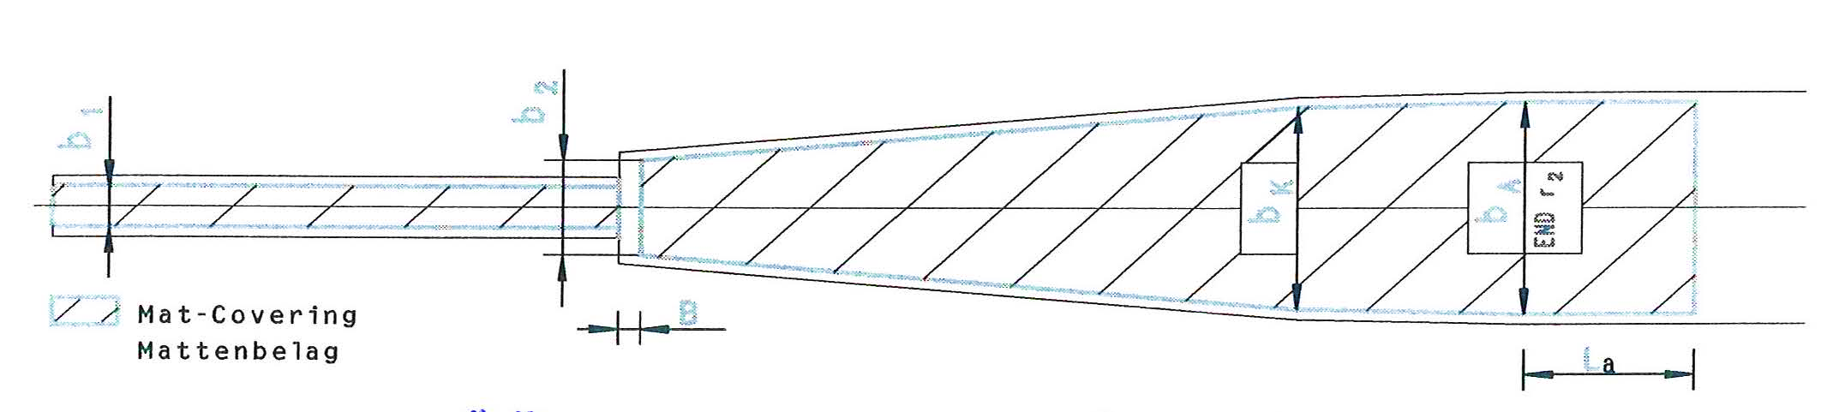

b 1 xxx m

b 2 xxx m

bk xxx m

bA xxx m

La xxx m

B xxx m

Remarks Xxx xxx xxx
After all requirements and conditions (written RED), mentioned in the report (beginning from top page 1), will be fulfilled, a new certificate for next 5 years can be issued.

Place and date xxx Signature inspector

Enclosed plans and/or drawings
-) xxx
Other enclosures
-) Matrix for Infrastructure Jumping Hills
-) calculation sheet NORM JUMP-3.5 (for new and reconstructed hills, if available)

Matrix for Infrastructure Jumping Hills name of the hill / HS: XXX
competition NH + LH  infrastructure | FIS Cup | COC | WC WSC OWG | JSWC | Tick/ Remark of Inspector
inrun
developing starting area with athlete stairs beside inrun line | x | individual
normal starting area with athlete stairs separate from the inrun line | x | x |  | x
well established starting area with lift | x | x | x | x
warm up room for 20 athlets and more | x | x | x | x
toilet |  |  | x
starting stairs | x | x | x | x
light starting bar | x | x | x | x
starting bar with start light |  |  | x
media stairs |  |  | x
snow track without cooling system | x
snow track with cooling system |  | x |  | x
ice track | x | x | x | x
tarpuline for track | x | x | x | x
snow blowers | x | x | x | x
optical signal for snow blowers | x | x | x | x
reachability of inrun track for snow blowers | x | x | x | x
measurement installation (startsignal, speed, wind) | x | x | x | x
safe stairs to reach the table (from coaches platform side) | x | x | x | x
hill / outrun
damp mats between table and knoll "B" | x | x | x | x
flexible marking "P" "K" "HS" |  |  | x
to beat laser |  |  | x
closed guard rails | x | x | x | x
access hatch (safe side door, K pt, knoll) for hill prep crew | x | x | x | x
safe stairs on both sides of hill | x | x | x | x
safe mounting element for video meassurement equipement | x | x | x | x
use of ladders is not possible | x | x | x | x
exitgate at right or left side (not in front) | x | x | x | x
judges tower
judges cabines in one level | x | x | x | x
judges cabines in split level, according to flight curve | x | x | x | x
room for race director |  |  | x
jury room above judges cabins | x | x | x | x
conference room (15 persones) |  |  | x
measurement installation |  |  | x
TV camera platform |  |  | x
trainer and team leader platform on the roof | x | x | x | x
safe stairs and tracks to reach all outside areas | x | x | x | x
ladder use is not possible | x | x | x | x
trainer platform
measurement installation |  | x | x | x
safe stairs and track to reach all standing positions | x | x | x | x
ladder use is not possible | x | x | x | x
floodlight
hill 1'000 lux |  | x |  | x
hill 1'000 lux WC/WSC |  |  | x
hill 2'000 lux OWG |  |  | x
emergency power supply | x | x | x | x
V 03.09.2018

